Annex 1

**Technical specification**

**Mid-tensioned 10 kV distribution system sockets with vacuum power switches**

1. CONDITIONS OF ENFORCEMENT:
   1. The performer (executor Vendor) manufactures the sockets of the mid-voltage 10 kV distribution equipment with vacuum power switches (hereinafter - equipment), taking into account the technical specifications in points 2, 3 and 4 and supplies them to RP SIA “Rīgas Traffic” (hereinafter - commissioning party) to the address: Latvia, Riga, Vestienas iela 35, zip code: LV-1035.
   2. Maximum delivery time for equipment not exceeding 6 (six) months from the order date.
   3. Equipment must be checked before delivery. Together with the offer, the Electrical Equipment Test Certificate or the Routine Test Report or equivalent document must be included. The presence of a representative of the manufacturer must be ensured at the installation's entry into service (after full assembly of the equipment) on-site.
   4. For the equipment supplied, the warranty period must be at least 24 (twenty-four) months from the time of delivery to the warehouse or from the time of installation and entry into service. If the commissioning party determines that the equipment supplied is not functioning due to the fault of the performer, or the equipment deficiencies/defects discovered cannot be rectified on site, or the equipment has been damaged as a result of transport, the performer must rectify the detected defects (and inform the commissioning party of the solution to the problem) for a period of not more than 14 (fourteen) days of the calendar in time.
2. GENERAL TECHNICAL REQUIREMENTS FOR DISTRIBUTION EQUIPMENT::
   1. Manufacturer: Tavrida Electric;
   2. Nominal voltage: 12kV;
   3. Nominal frequency: 50Hz;
   4. Primary bus nominal current: 1250A;
   5. Maximum temporal current allowed: 20kA;
   6. Short-term maximum current persistence: 3 seconds;
   7. Protection Class: IP4X;
   8. Colour: RAL7032;
   9. The distribution type “cassette”, closed type distribution equipment with a pull-down power switch;
   10. Control and control voltage: 230VAC;
   11. Socket lighting and heating voltage: 230VAC;
   12. Alarm lamp and indicator voltage: 24VDC;
   13. Visual indication of integrated power switch, ground knives and trolley position;
   14. Integrated Power Switch Local Control with Switch;
   15. Integrated indication of the presence of 10 kV voltage;
   16. Relay protection and automatically (RAA): Schneider Electric - MiCOM P111;
   17. Power switch control unit: Control module СМ_16, designed for voltage 230VAC;
   18. Integrated socket door electromechanical door lock;
   19. Integrated ground knife system with manual drive mechanism;
   20. All distribution sockets must be compatible with each other;
   21. Control cables connected from top;
   22. Equipment sockets must display a single-line diagram;
   23. Equipment sockets must bear inscriptions and notations in Latvian;
   24. Performance: Completely assembled distribution and wedged equipment;
   25. Optional special trolley for the carriage of the power switch;
   26. In addition, a special trolley for opening the socket blinds is provided for;
   27. Compliance with IEC standards.
3. ASSEMBLY OF DISTRIBUTION EQUIPMENT
   1. **Enter socket with vacuum power switch – 2 pieces.** 
      1. Socket width: 600 mm;
      2. Socket depth: 2356 mm;
      3. Nominal current: 630A;
      4. Pull-out element Cbunit_DOU16_LD1(Mile_150-20-630 C e220 CM);
      5. Integrated measuring unit certified in Latvia:

Current transformers 200/5/5/5 A, class 0,5 – 3 pieces;

Voltage converters 10000/100V, class 0,5 – 3 pieces;

* + 1. Relay protection and automation (RAA): Schneider Electric - MiCOM P111;
    2. Integrated network analyzer: Lumel ND20;
    3. Schematic image and electrical diagram:

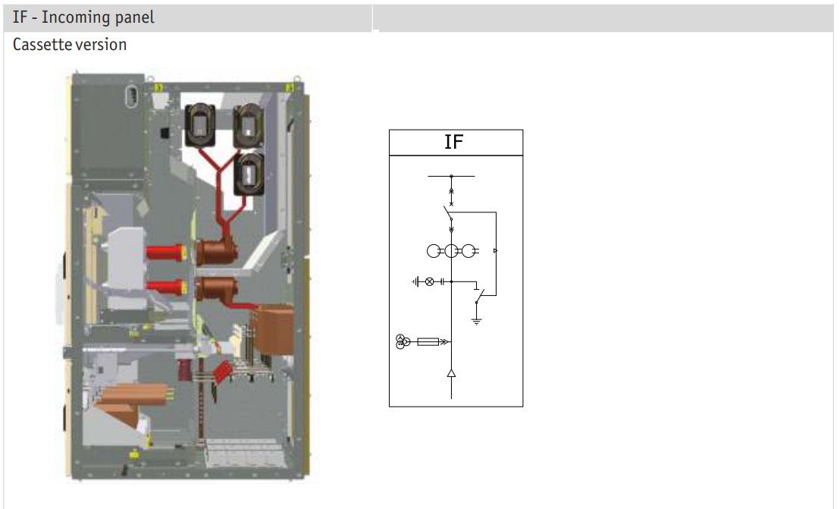

Image 2.1. Input cable socket

* 1. **Transformer protection socket with vacuum power switch – 2 pieces.**
     1. Socket width: 600 mm;
     2. Socket depth: 1355 mm;
     3. Socket depth: 2356 mm;
     4. Nominal current: 630A;
     5. Pull-out element Cbunit_DOU16_LD1(Mile_150-20-630 C e220 CM)
     6. Integrated measuring unit certified in Latvia 200/5/5 A, class 0,5 – 3 pieces;
     7. Relay protection and automation (RAA): Schneider Electric - MiCOM P111;
     8. Schematic image and electrical diagram:

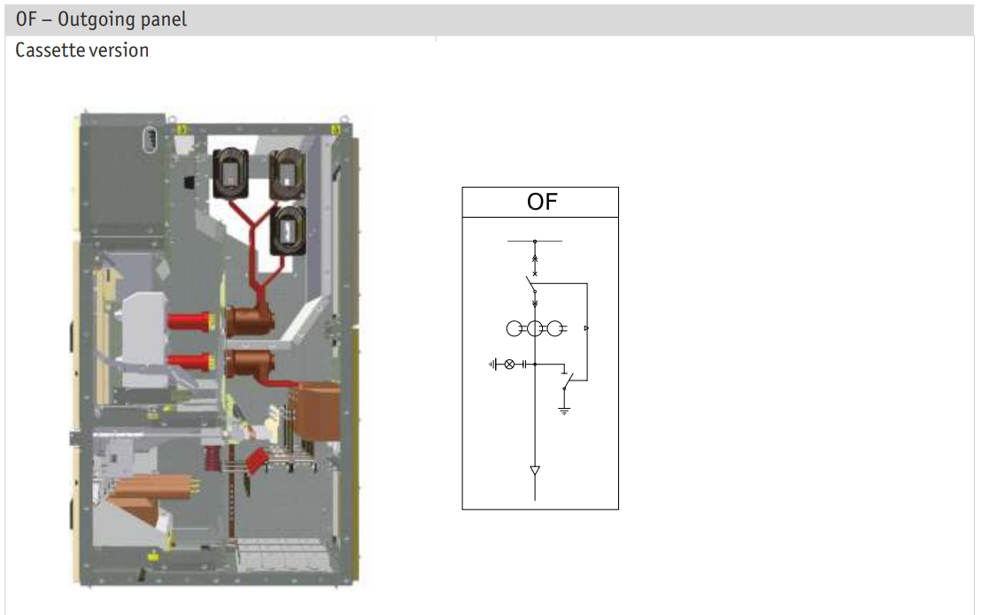

Image 2.2. Transformer protection socket

* 1. **Section socket with vacuum power switch – 1 piece.** 
     1. Socket width: 1000 mm;
     2. Socket depth: 1355 mm;
     3. Socket depth: 2356 mm;
     4. Nominal current: 630A;
     5. Pull-out element Cbunit_DOU16_LD1(Mile_150-20-630 C e220 CM);
     6. Schematic image and electrical diagram:

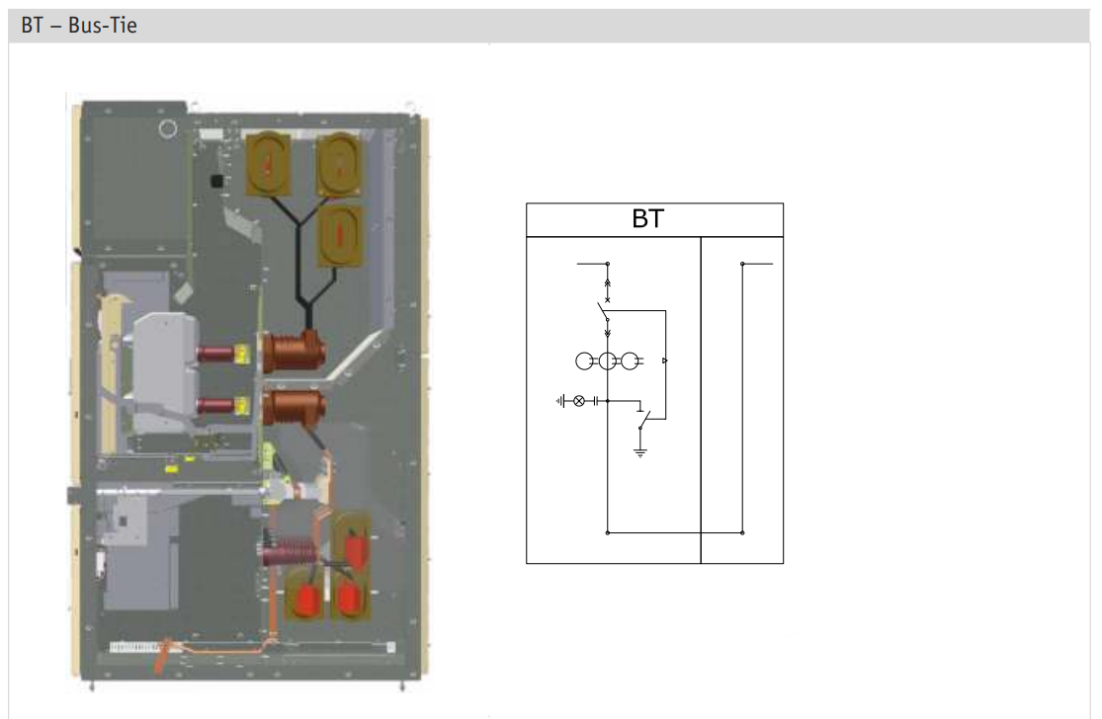

Image 2.3. Section socket

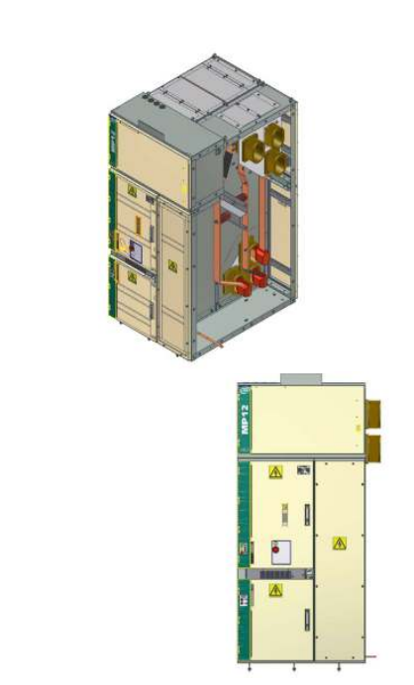 

Image 2.4. Section socket

* 1. **Self-consumption transformer chamber with transformer – 2 pieces.**
     1. Socket width: 1000 mm;
     2. Socket depth: 1355 mm;
     3. Socket depth: 2356 mm;
     4. Nominal current: 630A;
     5. Integrated transformer manual separator;
     6. Integrated transformer 10 kV power protection fuses;
     7. Integrated bus grounding knives;
     8. Integrated self-consumption transformer:
        1. Rated transformer power: 25-45kVA
        2. Primary winding voltage: 10000V
        3. Secondary winding voltage: 400V
        4. Primary voltage adjustment options: +/-2 x 2,5 %
        5. Operating frequency: 50 Hz
        6. Vector group: Dyn11
        7. Primary and secondary winding insulation classes: F/F
        8. Resistance to fire standard EN 60076: F1 or equivalent
        9. Electrical loss of idling: ≤ 200W
        10. Electrical loss at load (120oC): ≤ 1700W
        11. Weight: ≤ 380 kg
        12. Resistance to fire standard EN 60076: F1 or equivalent
        13. Climate resilience standard EN 60076: C2 or equivalent
        14. Environmental class standard EN 60076: E2 or equivalent
        15. Integrated winding temperature control relay
     9. Schematic image and electrical diagram:

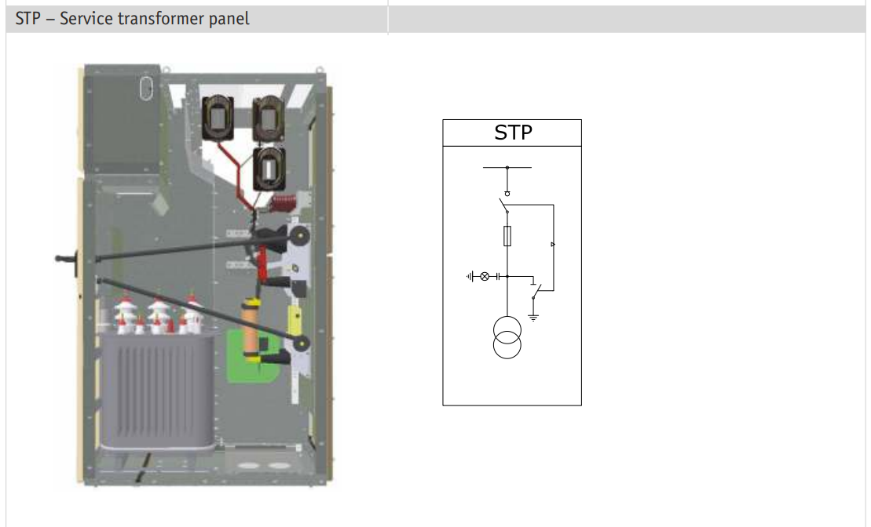

Image 2.5. Self-propelled transformer chamber

* If units of equipment cannot be placed in a single socket of a self-propelled transformer at point 2.4.5; 2.4.6; 2.4.7; 2.4.8, it is permissible to place transformers in separate enclosed sockets.

1. **Distribution equipment layout scheme:**
   1. Allocation equipment deployment option 1:

|  |  |  |  |  |  |  |
| --- | --- | --- | --- | --- | --- | --- |
| Self-consumption transformer socket | Lead cable socket No.1 | Transformer No.1 socket | Section socket | Transformer No.2 socket | Lead cable socket No.2 | Self-consumption transformer socket |

* 1. Allocation equipment deployment option 2:

|  |  |  |  |  |  |  |  |  |
| --- | --- | --- | --- | --- | --- | --- | --- | --- |
| Self-consumption transformer socket | Self-consumption transformer separator, fuses, stationary ground | Lead cable socket No.1 | Transformer No.1 socket | Section socket | Transformer No.2 socket | Lead cable socket No.2s | Self-consumption transformer separator, fuses, stationary ground | Self-consumption transformer socket |