PROPOSAL FOR MARKET RESEARCH
“Manufacture and Supply of Rail Grinding Blocks”

Date: ___ ______ 2026
- SUBMITTED BY
Company name *
Company registration number
*Hereinafter – the Tenderer
- CONTACT PERSON
Name, surname, position
Phone number
E-mail address

- MARKET RESEARCH TERMS
  - The subject of this market research is the manufacture and supply of rail grinding blocks (hereinafter – the Goods) for the municipal limited liability company “Rīgas satiksme” (hereinafter – the Contracting Authority).
  - The purpose of the market research is to purchase the subject matter described above.
  - The criterion for selection of the proposal is the lowest price.
  - The Contracting Authority reserves the right:
- not to select any proposal,
- to terminate or discontinue the market research without result.
  - The Contracting Authority has the right to correct arithmetic errors identified during the evaluation of proposals by notifying the Tenderer. Arithmetic errors shall be corrected as follows:
- recalculation shall be based on the unit prices indicated in the Tenderer’s offer;
- only corrected prices shall be considered in evaluation and comparison.
  - The Contracting Authority may verify compliance with qualification requirements and technical specifications only for the Tenderer offering the lowest price.
  - The Contracting Authority has the right to reject a Tenderer if the Tenderer (or its member/partner) has previously failed to fulfil contractual obligations with the Contracting Authority and less than three years have passed since contract termination.

- TENDERER’S DECLARATION
  - We hereby confirm that:
- the Tenderer is not insolvent, not under liquidation, its economic activity is not suspended;
- the Tenderer has no tax debts exceeding EUR 150.00;
- the Tenderer is not excluded from the VAT register (if applicable).
- The Tenderer is not subject to exclusion grounds under the International and National Sanctions Law of the Republic of Latvia.
- We hereby certify that Council Regulation (EU) 2025/2033 of 23 October 2025, amending Regulation (EU) No 833/2014 concerning restrictive measures in view of Russia’s actions destabilising the situation in Ukraine, in particular Article 5k(1), does not apply to the Tenderer.
- We confirm that goods originating from the Russian Federation or the Republic of Belarus are not included in the offer.
  - SUBCONTRACTORS (if applicable)
☐ The contract will be performed without subcontractors.
☐ Subcontractors will be involved:
Name / Registration No | Scope of work | Contract share
- PROPOSAL
  - The Tenderer shall submit the proposal by completing Annex 1.
  - Prices shall be indicated with accuracy up to two decimal places.
  - Estimated contract duration: 2 years.

- CONTACT INFORMATION
Contact person of the Contracting Authority: Procurement Specialist Natalja Vjatkina, e-mail: natalja.vjatkina@rigassatiksme.lv.

- INFORMATION ABOUT THE CONTRACTING AUTHORITY
The municipal limited liability company “Rīgas satiksme” was established on 20 February 2003. It is fully owned by the Riga City Municipality. The company operates according to internationally recognized standards:
- ISO 9001:2015 (Quality Management)
- ISO 45001:2018 (Occupational Health & Safety)
- ISO 50001:2018 (Energy Management)
More information here: (https://www.rigassatiksme.lv/lv/par-mums/publiskojama-informacija/sertifikati/).

ANNEXES
Annex 1 – Technical Specification and Tenderer’s Technical and Financial Proposal.
Annex 2 – Drawing (Grinding Block).

Annex 1
Technical Specification and Tenderer’s Proposal
Technical Specification
Rail grinding block
Model / designation: CP 14A F36
Application:
Rail grinding using a grinding tram
Technical parameters:
- Dimensions – according to attached drawing (Annex 2)
- Abrasive material – 14A (brown electrocorundum)
- Grit size – F36
- Bond – CP (Ceramic Pressed / vitrified bond)

Estimated quantity for 2 years: 2000 pcs.
On-demand ordering.
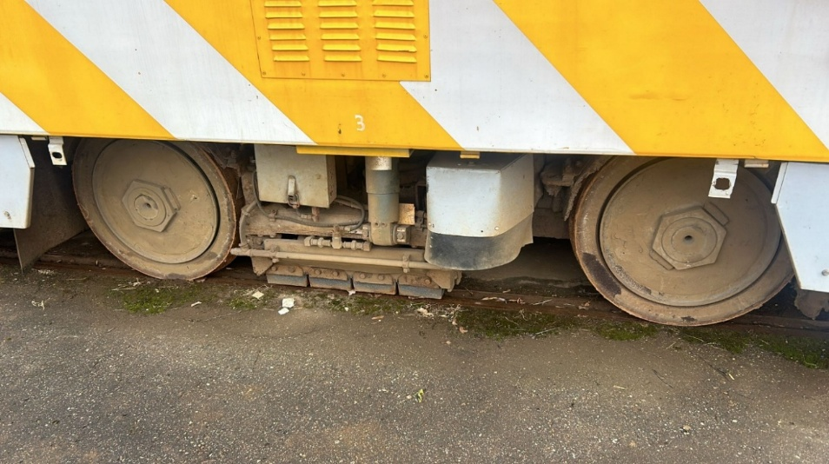

Tenderer’s Financial Proposal
Item | Unit | Unit price (EUR excl. VAT) | Quantity | Total  (EUR excl.VAT)
Rail grinding block | pcs. |  | 2000
One-time tooling cost | pcs. |  | 1
Total price

Delivery conditions | Tenderer`s response
Validity of the proposal
Delivery terms (Incoterms)
Delivery costs
Manufacturing and delivery time
Payment terms
Technical compliance | Please indicate compliance with the technical specification.
Other conditions ensuring validity of the offered price

Annex 2
